Camden People First
Referral form

Camden People First
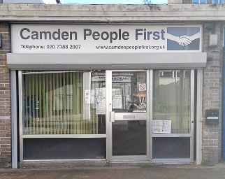
215 Eversholt Street
Ampthill Square
London NW1 1DE
Email : info@camdenpeoplefirst.co.uk
Call : 0207 388 2007

This referral form is private and confidential

What is your full name?
______________________________
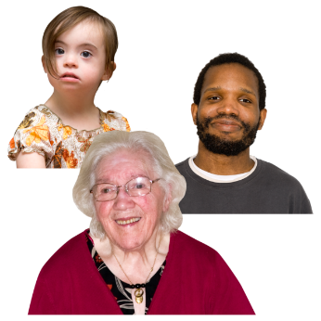

How old are you? (Age)
______________________________

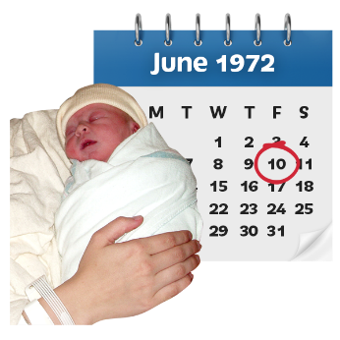
When were you born? (Date of birth)
______________________________

Are you a Male or Female? (Please tick one)
Male Female Other

What is your number?

Mobile: _________________________

Telephone number: ________________

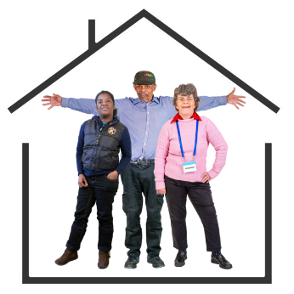
Where do you live? (Address)
______________________________
______________________________
______________________________

Who told you about Camden People First?
______________________________

How do you know the person?
______________________________

Where do they live?
______________________________
______________________________
______________________________

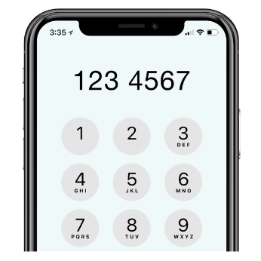
What is their number?

Mobile: _________________________

Telephone number: ________________

Why were you sent to us?
(We will contact the person who sent you)
______________________________

Who did you speak to in Camden People First?
______________________________

When did you speak to them? (Date)________

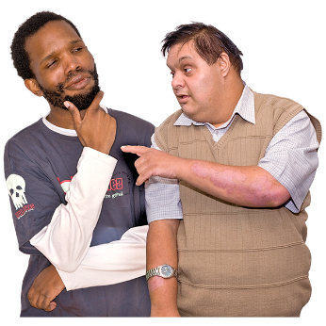
How did you hear about Camden People First?:
e.g. CLDS, website, someone told you, etc.
______________________________

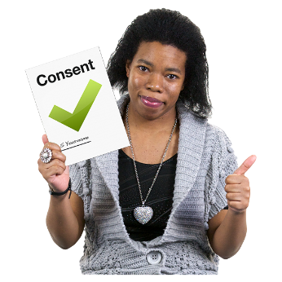
Please remember: In line with Data Protection Act 2018 we need to make sure we have your consent to keep and record private data.
All information will be private and only used when it is needed.

Please tick to give your consent

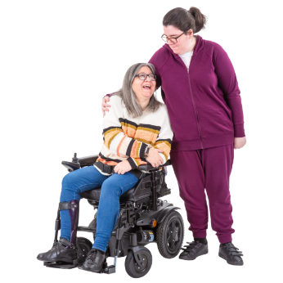
Are there any important people we could contact?
(i.e. family, carer, house manager, someone else)
What is their name? | What is their job or how do you know them? | Where do they live? | What is their number and email?

(To be filled out by the advocate)
Monitoring and Evaluation | Date
Referral Case/Category:
Summary of action taken:
Case closed:
Feedback request sent:

Additional information
(To be filled out by the advocate)

Is the referral urgent?
______________________________

Is there a timescale for it to be completed?
______________________________

What are their living arrangements?
Residential / Supported / Family / Other

Please circle one. If other, please say where.
______________________________

Ethnicity/ religion:
______________________________
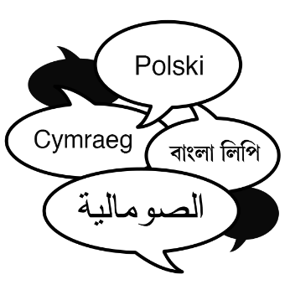
Language:
______________________________

Has the person asked for an advocate? (please give details):
______________________________

Does the person have any communication needs or difficulties?
______________________________
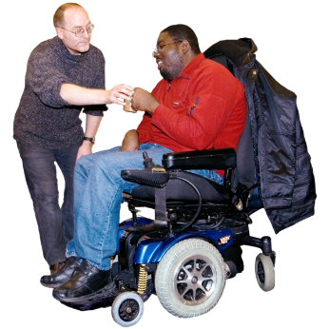

Are there any medical or physical issues we need to know?
______________________________

Are there any behaviour issues we should know of, or any other useful information?
______________________________

