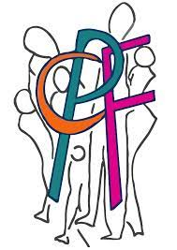
Camden People First
Easy Read documents

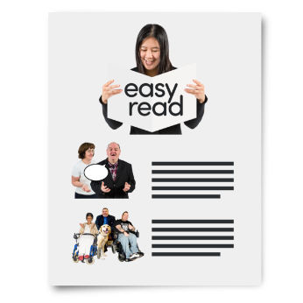
This is an example of an Easy Read document made by Camden People First.

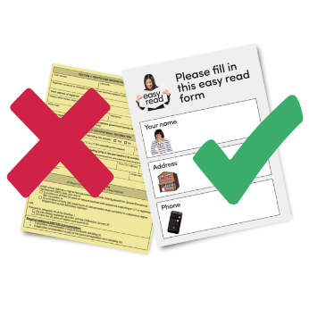

At Camden People First, we have a team of people with learning difficulties who work together to change big words into easy words.

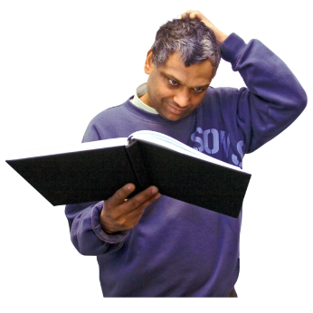

We also use pictures to help you if you get stuck.

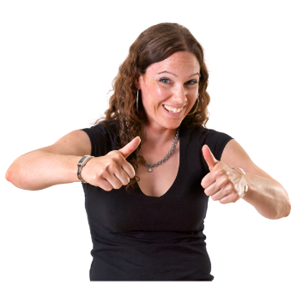

This makes it easy for other people who cannot read to understand what the document says.

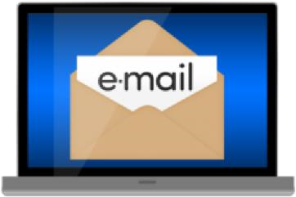
If you need anything put into Easy Read, please email us on info@camdenpeoplefirst.co.uk

