**Tell us what you think about Camden People First**

How did we do?



**Name**:______________________________________________________________

(You do not have to tell us if you do not want to)



**Please tick**

**Gender:**



Male Female Prefer not to say

**Sexuality:**

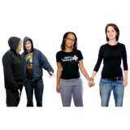

Straight Gay Lesbian

Transsexual Prefer Not To Say

**W**

**Age:**

18-25 26-30 31-35 36-40 41-45 46-50 51-55



56-60 61-65 Over 65 Prefer not to say

**Religion:**



Christian Hindu Buddhism



Sikhism Jewish Islam



None Others Prefer not to say

**How did you hear about our service?**

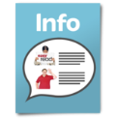

Internet Leaflets Drop in Centre



Friend Newspaper



Other - please tell us: ________________________________________



**About the Staff**

**Were the staff friendly?**





Yes No



If **yes** - Tell us why were they friendly? ______________________________

____________________________________________________________________



If **No** - Why were they not friendly? _________________________________

____________________________________________________________________

**Were the staff helpful?**

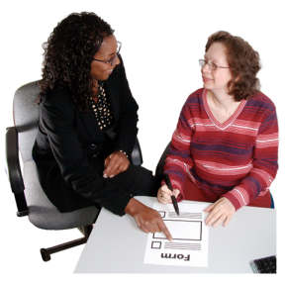



Yes No

**Were the staff supportive?**

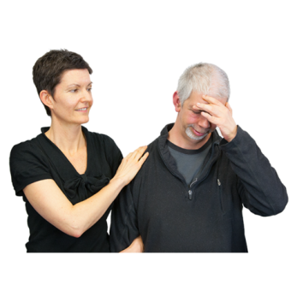



Yes No

**Did the staff listen to you?**

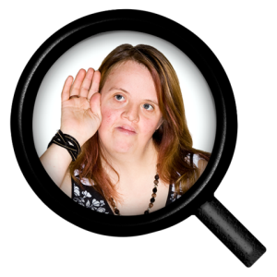



Yes No

**Were they patient with you?**

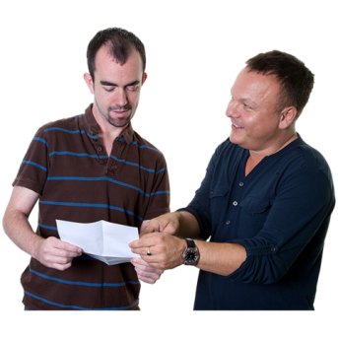



Yes No

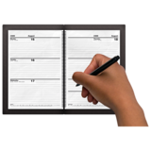

**Making Appointments**

**Were appointments easy to arrange?**



Yes No

**Information**

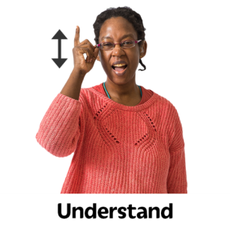

**Did you understand what the staff was saying?**



Yes  No

**Were you happy with our services?**

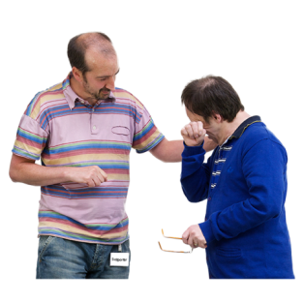



Yes No

**What service were you happy with?**

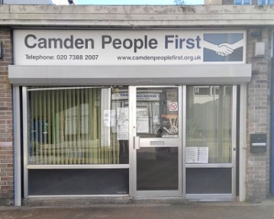

Advice on the phone Drop in advice at our office





Healthy Eating Club Disco Club



Disability Hate/Mate crime advice

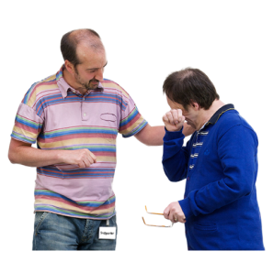

Volunteering Staff

**Do you think that CPF should be doing any other project?**



Yes No



If **Yes** – What project?

**Did you find information on Disability Hate and Mate crime helpful in getting a result?**







Yes No



If you said **YES** – Please tell us why?

_____________________________________________________________________





­­­­­­­­­­­If you said **NO** – Please tell us why?

_____________________________________________________________________

**Do you have an advocate or someone to help you to speak up?**

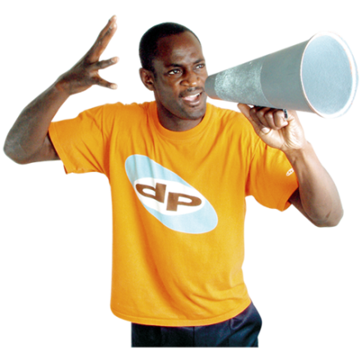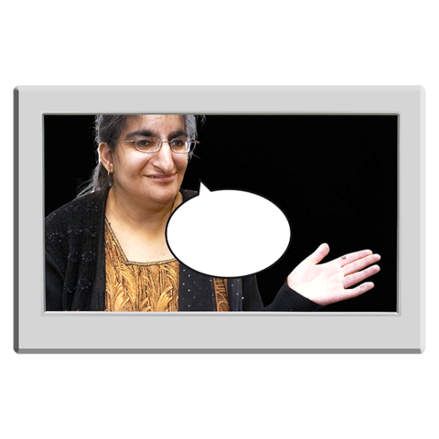





Yes No

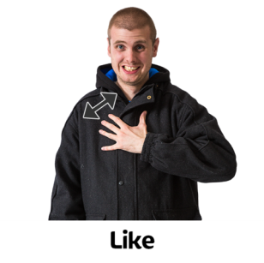If you don’t have an advocate - would you like one?





Yes No

If you have an advocate - how many times do you meet up?

**Once** a week  2 times a week

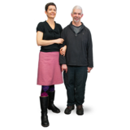 

**3** times a week **4-5** times per week **Once** every 2 weeks

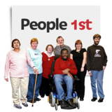

**Once** a month Less than **once** a month

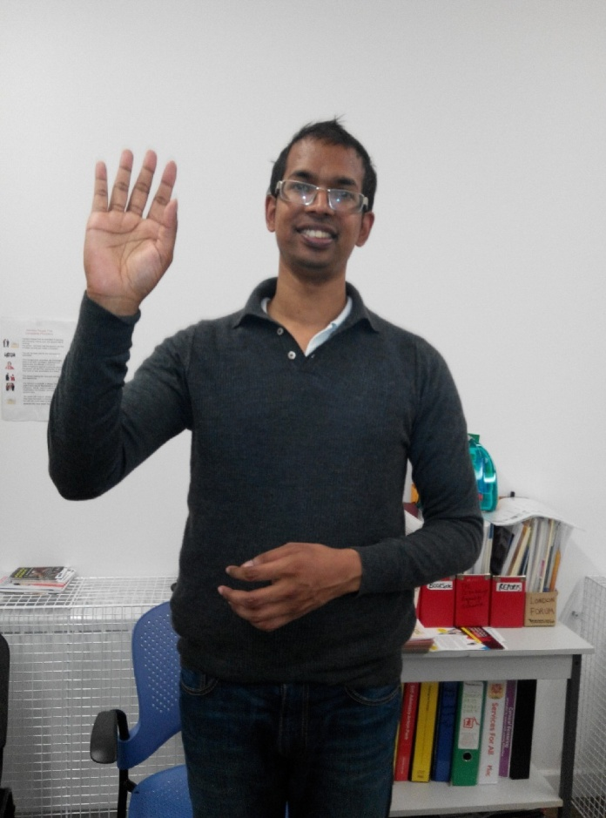

**Thank you for giving us your feedback.**

**Sanjay at Camden People First**